ELDORA Upgrade – Data Synchronization

Overview:

There are two sources of data, radar and housekeeping data, which must be synchronized in time to ensure for proper alignment when both data sources are merged within the radar processor PC. Both sets of data will be synchronized to IRIG-B and 1 PPS, made available by the GPS receiver and will be time stamped concurrently upon each beam, a.k.a dwell. The housekeeping data will be sent via Ethernet to the radar processor PC where the data streams will be aligned and merged.

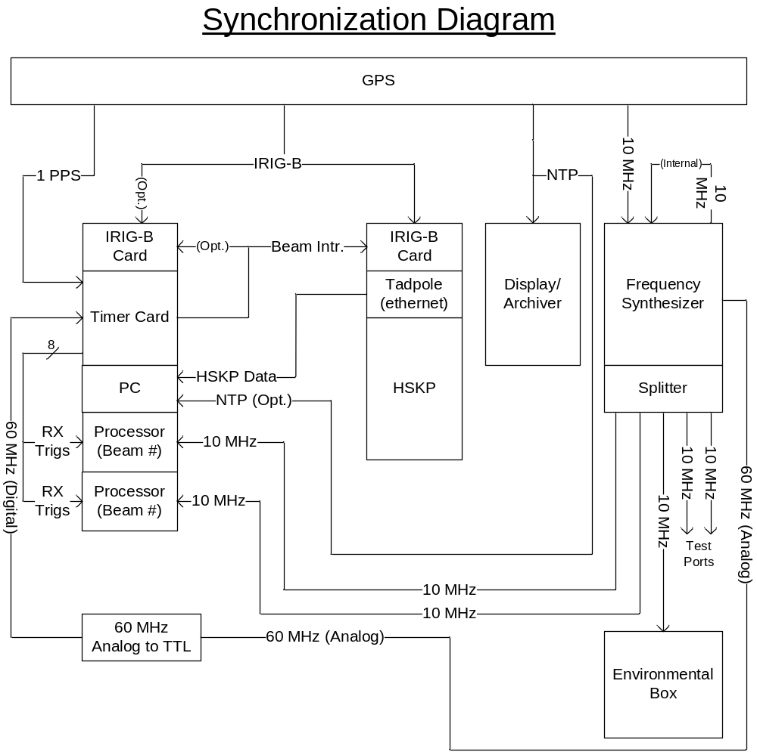

GPS Receiver:

The GPS receiver will send IRIG-B time code to the IRIG-B time cards. It will also send 1 PPS to the Bittware Pulse Timing Card used to trigger the start of the radar timing.

IRIG-B Cards:

IRIG-B time code will be supplied, by the GPS receiver, to both IRIG-B time cards, one in the housekeeper and the other in the radar processor PC. Within the housekeeper, the IRIG-B card will provide a time stamp for the housekeeping data. This time stamp will occur for each beam when a hardware based “beam interrupt” is provided by the Bittware pulse timing card. Within the radar processor PC, the IRIG-B card will provide the “start time” of the radar which will be used in calculating the time associated with each radar beam.

Bittware Pulse Timing Card:

The Bittware Pulse Timing Card resides within the radar processor PC. This card will synchronize to the 10 MHz clock reference, via the 60 MHz digital clock, and 1 PPS of the GPS receiver. When it is determined that the radar is ready to operate, the pulse timing card will begin to output the programmed pulse signals upon the next 1 PPS which will mark the “start time” of the radar. A “beam interrupt” will be output to the housekeeper IRIG-B card to trigger an event time capture which will be used to time stamp the housekeeping data. This card is also responsible for generating transmit and receive triggers for the transmitters and the radar processors.

(Optional Radar Processor IRIG-B Time Code):

The radar processor IRIG-B time card is also capable of capturing time, based on an externally driven event, just as the housekeeper IRIG-B time card. The same “beam interrupt” can be used to capture the time code of the radar processor PC which can then be read and used to double check the data synchronization or for any other purpose.

Radar Processors:

The radar processors are free running and only process available data when receive triggers are present. Upon starting of the radar, the processors will be ready and waiting to process data once the receive pulses are provided by the Bittware pulse timing card. Each radar processor will keep track of the “beam count” which will be tagged to the start of each beam of data. The “beam count” will start at ‘0’ for the first beam and increment each beam thereafter. The “beam count” will be used along with the recorded radar “start time” to calculate the exact time of each beam. The calculation is as follows...

Time = Start Time + Beam Count * Beam Time

where “Beam Time” is the time per dwell. After the exact time is calculated for each beam, it can be aligned and merged with the housekeeping data.
Tadpole CPU Card (Ethernet):

The Tadpole CPU card will use its Ethernet port to send the housekeeping data to the radar processor PC where it will be merged with the radar data.

NTP

Network Time Protocol will provide synchronous time to the Display/Archiver PC and optionally to the Processor PC. This will allow for accurate time stamping.

10 MHz

10 MHz will be taken from the GPS Receiver unit and sent directly to the Frequency Synthesizer Chassis where it will then be split 5 ways. 10 MHz will be distributed from the splitter directly the 2 Processor Cards, Environmental Box, and 2 open test ports.

The 10 MHz Ovenized Oscillator within the frequency synthesizer will be available as an optional 10 MHz source for use without GPS.

60 MHz

60 MHz is produced within the Frequency Synthesizer based upon the provided 10 MHz. This 60 MHz analog signal is sent to the processor rack where it is converted to 60 MHz digital before being sent to the Bittware Pulse Timing Card. The timing card uses the 60 MHz digital clock as a system synchronous clock source to produce timing pulses.

